Expanding the frontier of the Brazilian National Research and Education Network (NREN) to build the National Innovation Network

Fausto Vetter; André Marins; Iara Machado; Nelson Simões

[fausto.vetter;andre.marins;iara.machado;nelson.simoes]@rnp.br

Rede Nacional de Ensino e Pesquisa (RNP)

José Alberto Sampaio Aranha

presidencia@anprotec.org.br

Associação Nacional de Entidades Promotoras de Empreendimentos Inovadores (ANPROTEC)

Key-words: Technology and Science Parks; Network; Innovation promotion environments; Innovation; Entrepreneurship

The Brazilian National Research and Education Network (NREN), known as Rede Nacional de Ensino e Pesquisa (RNP)[1], is a nonprofit organisation responsible to develop and maintain the RNP System, formed by the following components: (i) the Ipê national network (backbone) and its Points of Presence (PoPs) and Aggregation Points in the Federation Units; (ii) the Community Metropolitan Networks, based on the associative model of the User Organisations; (iii) the User Organisations, public or private; and (iv) the Collaboration Communities Networks.

ANPROTEC, created in 1987 as Associação Nacional de Entidades Promotoras de Empreendimentos Inovadores (ANPROTEC)[2], or the National Association of Entities Promoting Innovative Enterprises, is directly involved in the development of Brazilian business incubators and science parks, leveraging the consolidation of one of the largest systems of science parks and business incubators in the world. Brazil sums up to 369 business incubators, 90 science parks and 35 business accelerators. ANPROTEC follows contributing with the aim that the innovative entrepreneurship become the decisive way for the Brazil sustainable development.

The Brazilian legal framework[3] defines innovation promotion environments as favourable spaces for innovation and entrepreneurship, which constitute the proper environments for the knowledge based economy, involving two dimensions:

1. Innovation ecosystems: spaces aggregating infrastructure and institutional and cultural arrangements to attract entrepreneurs and financial resources to potentialize the development of the knowledge society (science parks, smart cities, innovation districts and technological centres); and
2. Business generation mechanisms: mechanisms to promote innovative enterprises and support the development of early stage technology based enterprises (business incubators, business accelerators, co-workings and open laboratories).

RNP and ANPROTEC are moving together to leverage a National Innovation Network by offering RNP cyberinfrastructure and services as an innovation platform to science and technology parks amongst other players. To achieve such a goal, RNP and ANPROTEC have decided to undergo a pilot project inviting 6 science parks to establish the conditions for the admission and participation of innovation promotion environments as RNP System User Organisations. ANPROTEC has indicated the following associated science parks:

* Zenit[4] - Porto Alegre, Rio Grande do Sul
* UFRJ Park[5] - Rio de Janeiro, Rio de Janeiro
* São José dos Campos Park[6] - São José dos Campos, São Paulo
* BIOTIC[7] - Brasília, Federal District
* Guamá[8] - Belém, Pará
* CITTA[9] - Campina Grande, Paraíba

The specific objectives of the pilot are:

1. Understand innovation promotion environments and its needs in terms of information and communication technology (ICT);
2. Understand the National Innovation Network concept through the RNP System;
3. Define how RNP position itself to offer its Cyberinfrastructure as an Innovation Platform;
4. Run a viability analysis on each participant to provide connectivity to the RNP network;
5. Define RNP System connectivity models for innovation promotion environments;
6. Evaluate policies and technical requirements to build an RNP System Service Catalog for innovation promotion environments;
7. Create a business and governance models to admit innovation promotion environments in the RNP System, and
8. Define a process to qualify and admit innovation promotion environments in the RNP System.

Below it is shown the locations of the technological and science parks participating in the pilot:

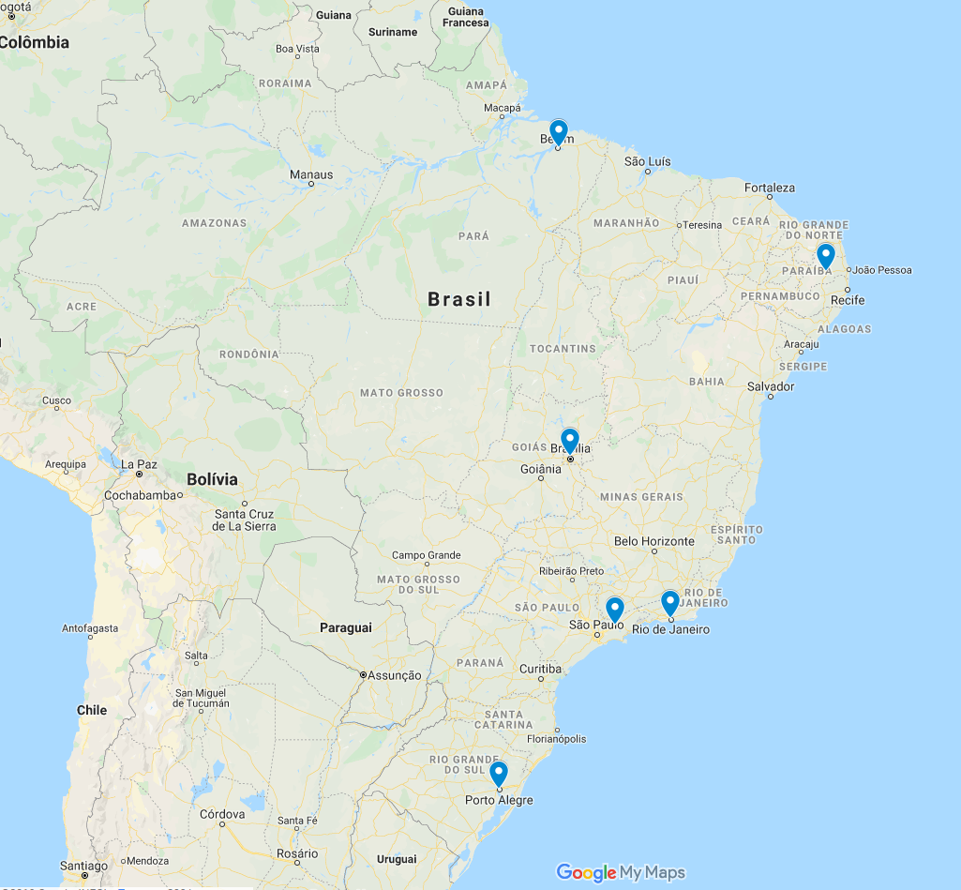

The pilot has started in October 2019, consisting of an invitation to the 6 indicated science parks. They were presented to the RNP System, the benefits of becoming part of it and the key objectives of the pilot. All of them declared interest in collaborating on the pilot and indicated both administrative and technical contacts. A process combining interviews and a survey has been carried on with all of them intending to understand the reality of a science park in contrast of the current User Organisations of RNP. The pilot will be carried out initially for 6 months, when the science park will have a taste of the current services RNP is able to offer them. During this pilot, the intention is to build the building blocks to enable the establishment of a long term relationship with this new User Organisation community.

1. RNP website: https://www.rnp.br/
2. ANPROTEC website: http://anprotec.org.br/
3. Article 2nd - Chapter I - Decree Number 9.283 - 7 February 2018 - Issued on D.O.U. in 8 February 2018
4. Zenit website: https://www.ufrgs.br/zenit/
5. UFRJ Park website: https://www.parque.ufrj.br/
6. São José dos Campos Park website: http://www.pqtec.org.br/
7. BIOTIC website: https://www.bioticsa.com.br/
8. Guamá website: http://pctguama.org.br/
9. CITTA website: http://www.citta.org.br/